**Final Project**

**AnishSharma Group**

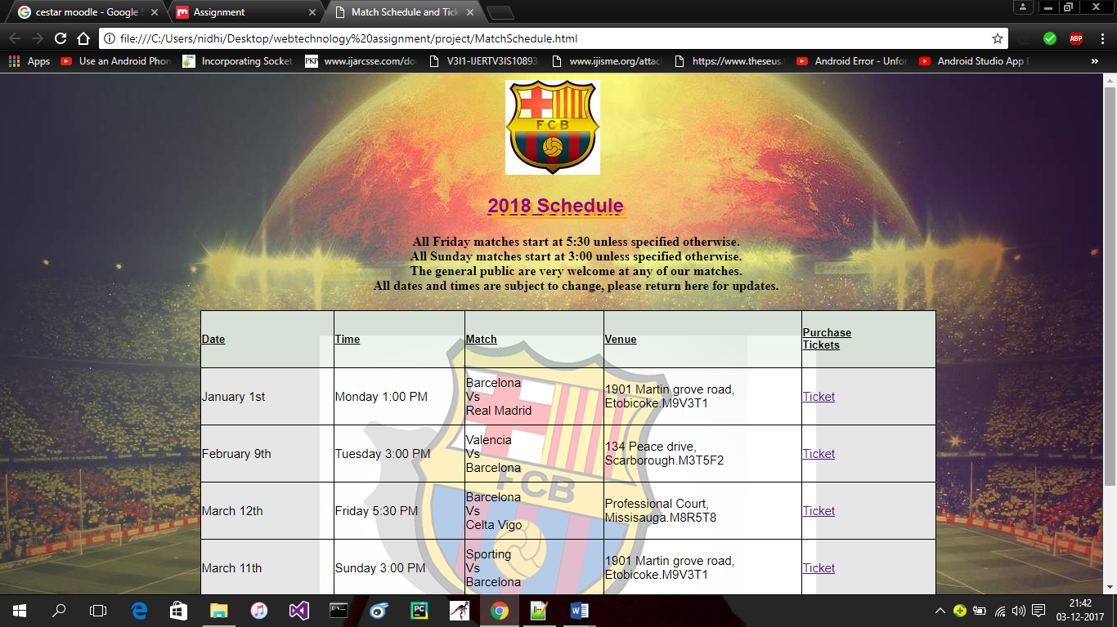 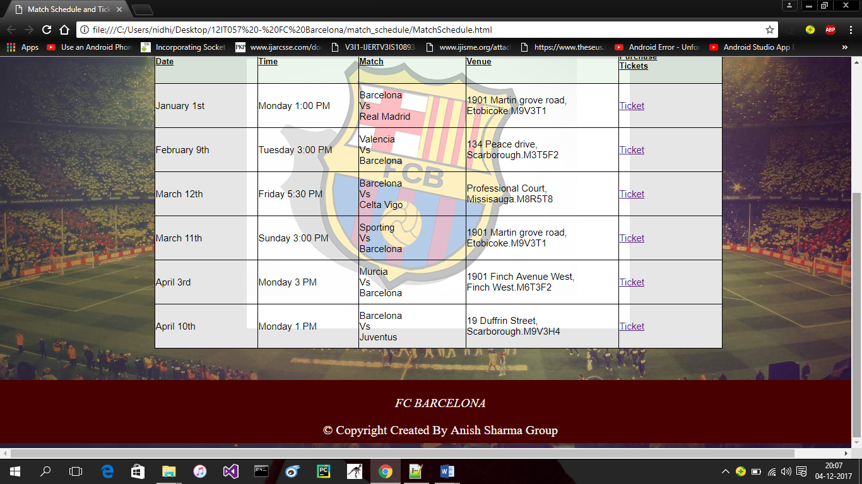

**MatchSchedule.html:**

MatchSchedule page contains HTML tags like: body, article, table, style, head. It contains css properties for background, margin, border and position.

This page describes the match schedule for upcoming matches, their date, venue and the link for book the ticket.

This page redirects on another page after clicking the Ticket link as below.

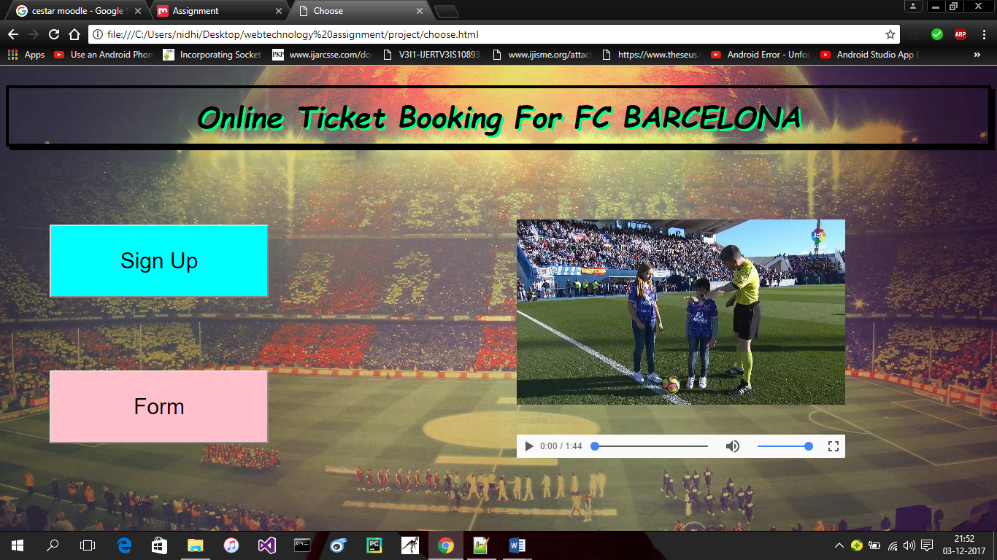

**Choose.html:**

This page contains title element, style element, body element, heading tag, div element, video tag, script tag to hold the javascript function.

It uses the css styles for background, border, text, element’s position, color.

Two buttons Sign Up and Book your ticket redirects to two another pages Registration form and the Ticket booking page.

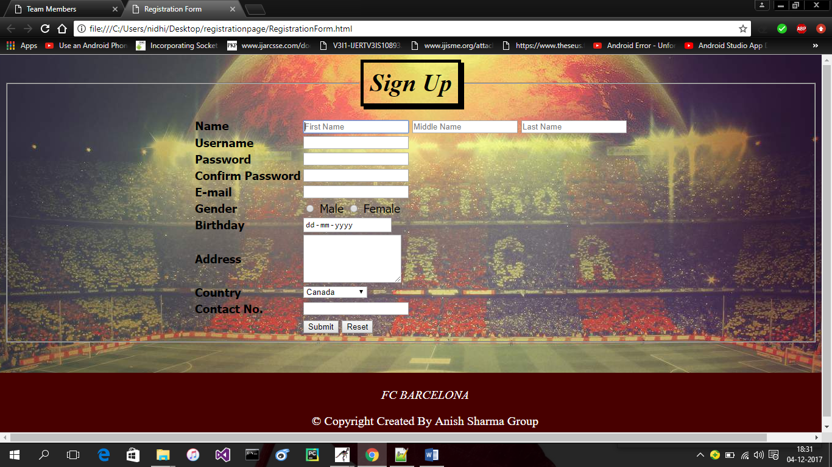

**RegistrationForm.html:**

Registration form contains title element to give title to the page, style element to hold the css properties, body element, form element to hold the whole form, table element, fieldset to group different form elements and legend tag to give title of the fieldset.

Two buttons submit and reset will submit and reset the entered information to the server.

It uses the css style to set the background, padding for element’s content, border, and font.

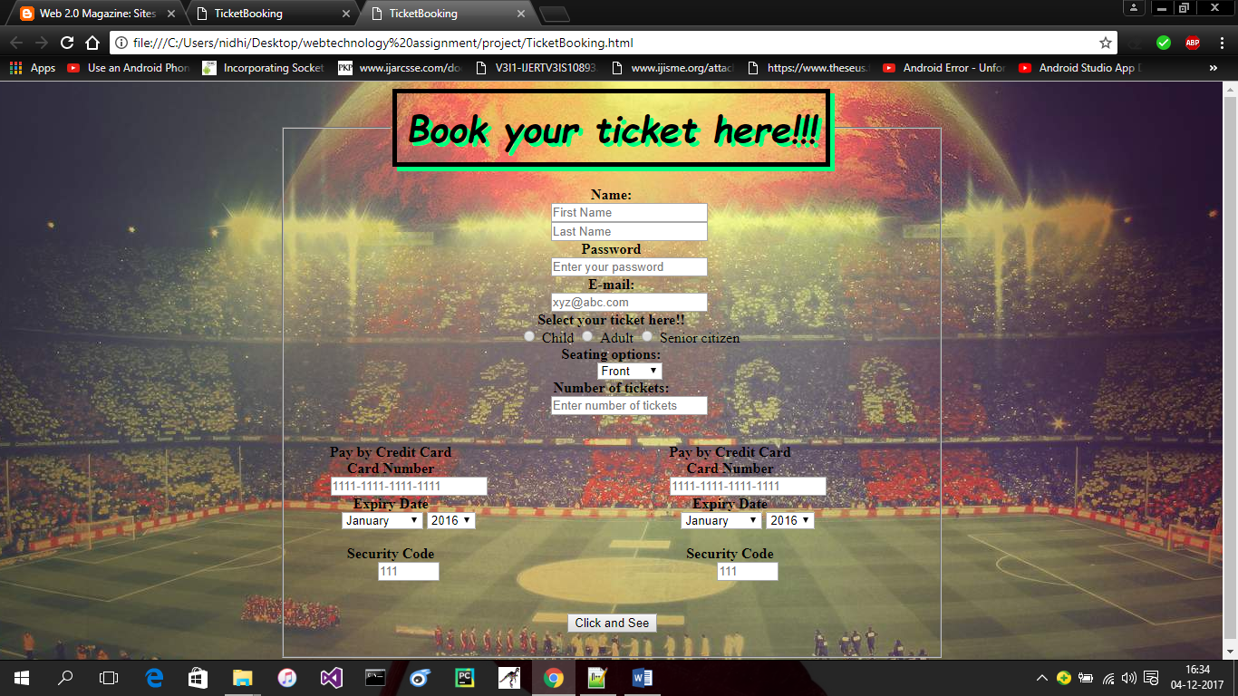 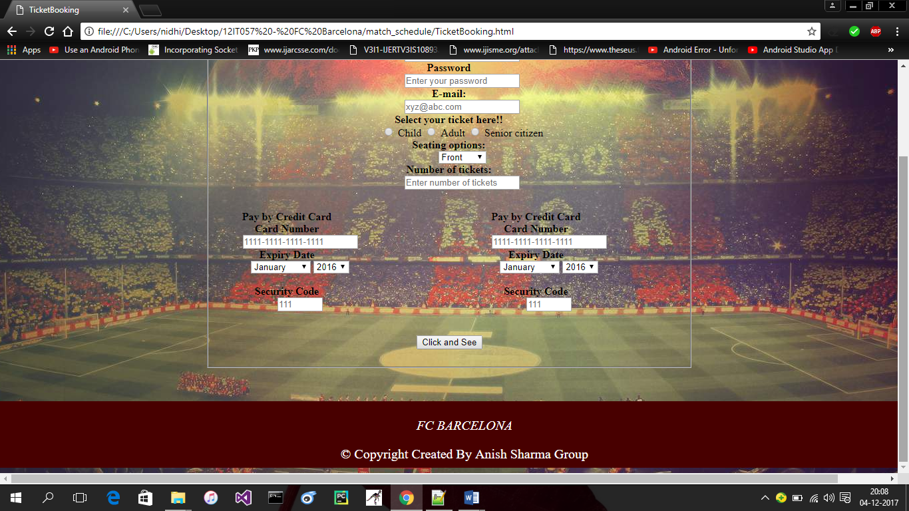

**TicketBooking.html:**

TicketBooking page is used to book the tickets for upcoming matches. For that first user have to register themselves in Registration form and after that they can use their password for ticketbooking page. Once the user click the button click and see they will redirect to another page welcome.html.

This page contains css properties for text, background, border.

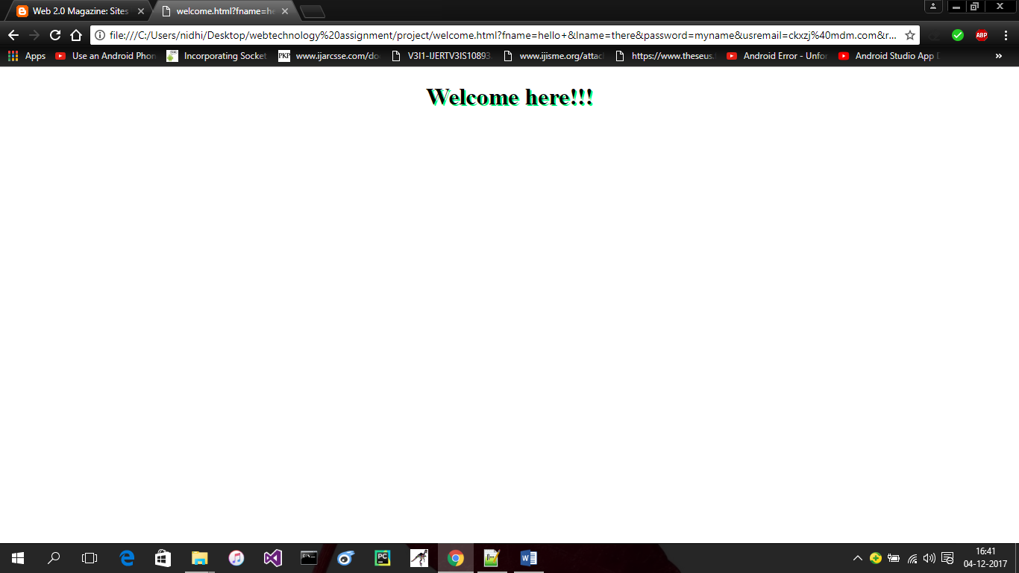

**Welcome.html:**

This page contains only one heading tag. And css properties for text. This page will open when user will enter information and click the button click and see on TicketBooking.html.